Yifeng Liao, Talal Al-Otaibi
ME 348F Advanced Mechatronics II
Professor Zhou
November 9, 2022
Lab 5 Report

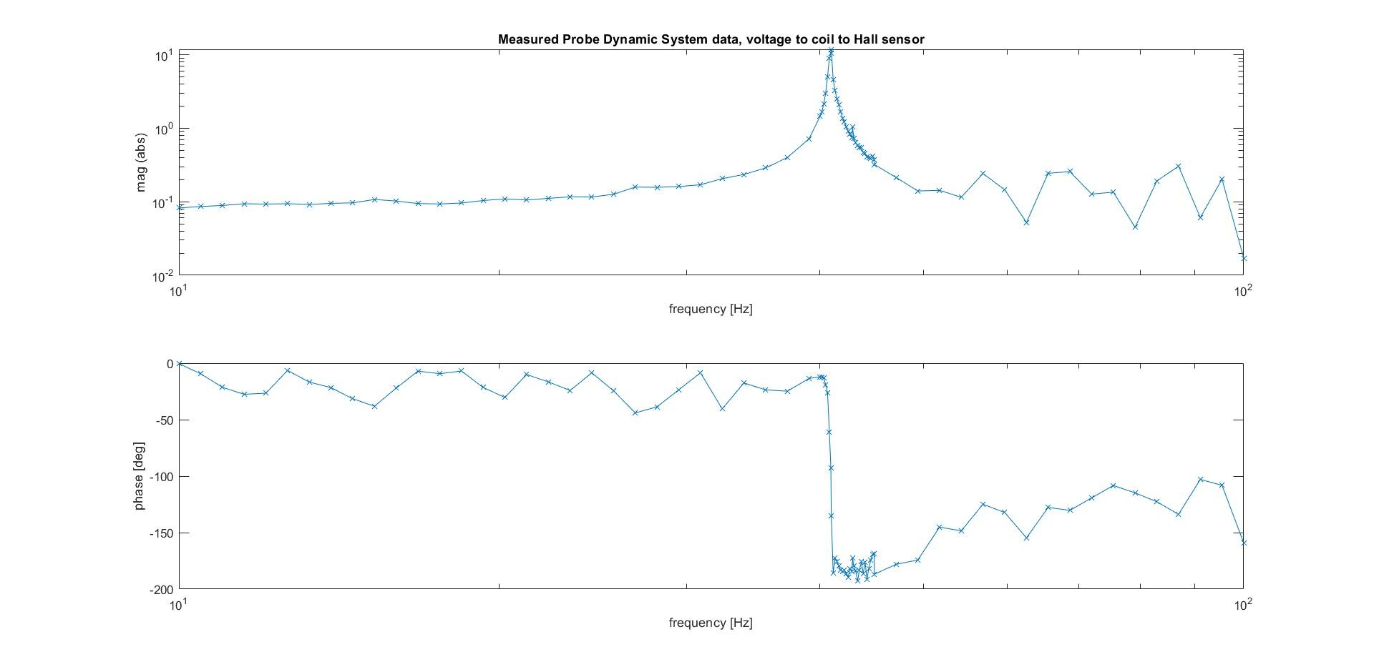
Figure 1

Figure 1 shows the experimentally measured frequency response of a macro-scale AFM probe, where the input is the voltage to the coil, and output is the Hall effect sensor’s voltage. The observed resonance frequency of the probe is 41 Hz. Note that the ‘jumpiness’ of the data past the resonant frequency is possibly explained by the magnitude attenuation resulting in a low signal to noise ratio.

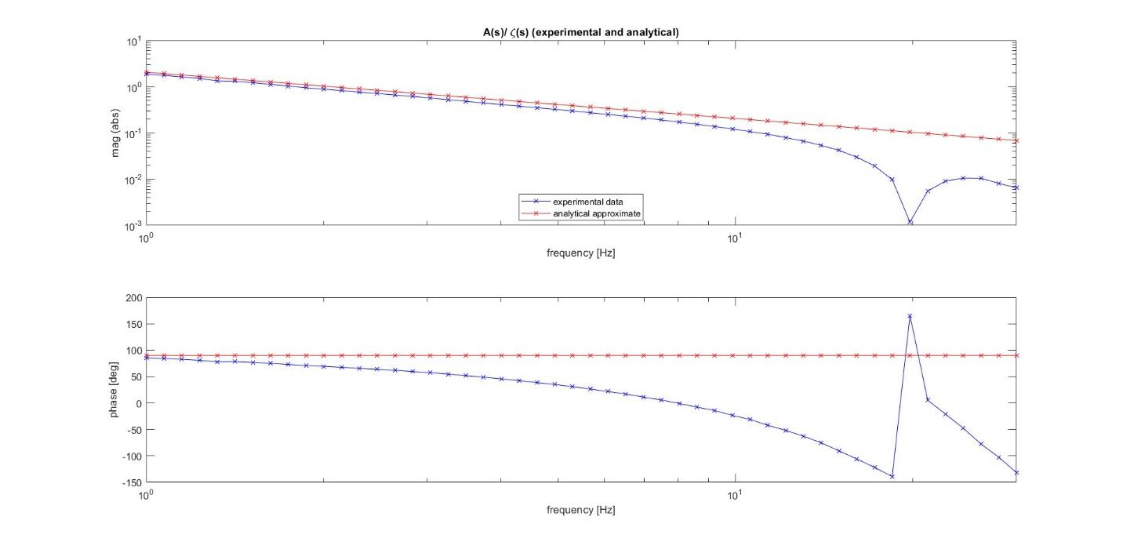
Figure 2
Figure 2 shows the frequency response of the plant A(s) / ζ(s), where A(s) is the envelope magnitude of the oscillation signal, and ζ(s) is the damping ratio that is injected into the system. It can be observed that the magnitude of the experimental measurement is similar to the analytical approximation until 20 Hz, this is because the probe’s resonance frequency is 41 Hz, therefore the envelope of the oscillation can be seen as a signal with 41 Hz sampling frequency. As a result, the Nyquist frequency is only 20.5 Hz, justifying the nonlinearity after 20 Hz. The experimentally measured phase starts from the same point as the analytical approximation, but it does not stay constant at 90 degrees; this is because in reality, the system itself in actuality is a nonlinear system, and we attempted to linearize it using a first order Taylor series expansion when carrying out an analytical approximation, hence the approximation is only good for low frequencies.

After the plant frequency response is obtained, we tuned the PI controller according to the frequency response and the step response of the system when the probe is oscillating in free air. The final self-resonance controller parameters are as follows: K_{p} = -0.54, T_{i} = 1; these parameters allowed the system to react quickly and track the envelope magnitude perfectly.

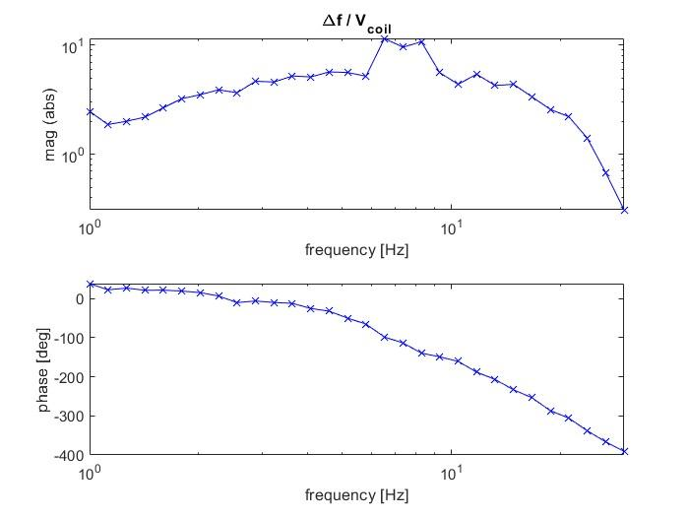
Figure 3

Note that in order to match the lab instructions plots, figure 3 shows data of the measured frequency of the probe directly rather than the difference between the reference and actual measured frequency (reference minus measured value). Magnitudinally, this slightly offsets the actual frequency response yet the trend stays the same.

In terms of the reference frequency, moving the micrometer upwards to barely contact the probe resulted in the adjusted resonant frequency being 43.6 Hz, being slightly above the 41 Hz when the probe resonates freely in air.

Selection of an optimal Ti_tracking value corresponds to effective integral control, where the integral control parameter Ki is defined to be equal to 1/Ti_tracking . Selection of a higher Ki, i.e lower Ti_tracking ensures the elimination of steady-state error. However, if Ti_tracking is too low, then the settling time is far too high to collect reliable readings quickly enough using the probe.

By moving the micrometer upward to create a resonant frequency higher than the reference, the controller is then turned on, and the response properties of steady state error (between adjusted reference and frequency reading), overshoot and system response time based on the control effort were observed. From there, Ti_tracking was iteratively tuned with trial and error until the overshoot was kept at a reasonably minimal level, the steady state error eliminated, and settling time that is quick enough.

A balanced value of Ti_tracking at 1.7 with T_{LP} of the lowpass filter kept at the default 5 Hz ensured the best results.

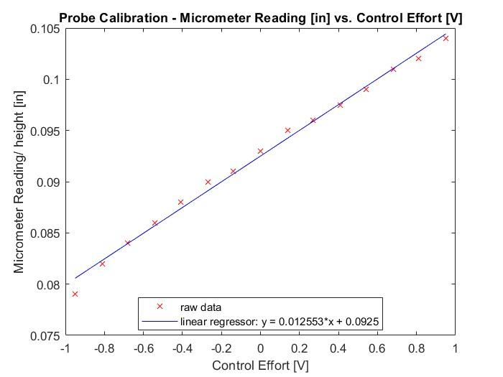
Figure 4
Figure 4 summarizes an attempt to calibrate the micrometer reading based on a range of control effort values from -1 to 1 V with 15 readings. The data seemed rather linear and thus a linear regression was a suitable approach. A linear regression fit reveals an R-squared value of 0.993 and a y- intercept 0.0925 in and a slope of 0.012553 in/V. A y-intercept simply means that 0 control effort can be interpolated as a reading of 0.0925in on the micrometer. Within -1 to 1V, it is safe to operate under the assumption of a linear model. Any nonlinearities can arise due to the fact that the contact between the probe and micrometer surface introduces a contact force input to the system model in conjunction with the force exerted by the coil (inductive/magnetic effect). As a result, the system dynamics are altered than what is expected and thus nonlinearities can be expected due to the physical contact force.

The linear fit is asymmetric about the zero tracking current point (v_coil = 0). When the control effort is negative, the micrometer reading is positive but does not mirror the values when the control effort is positive. That is to say, the plot does not form the shape of a V or have values that mirror each other around the y-axis.

This is best explained by the fact that below the y -intercept of 0.0925 in, the micrometer is raised such that there is less contact/vibrating clearance before the probe tip touches the micrometer surface. Subsequently, the resonant frequency lies higher than the adjusted reference of 43.6 Hz and so the control effort bias is negative in order to lower it back to the reference value. When the control effort is positive, the micrometer reading is larger than the y-intercept. This means that the micrometer surface is lowered and thus there is more clearance for the probe to oscillate before the tip contacts the micrometer surface (more room). As a result, the observed resonant frequency falls below the reference and thus a positive control effort bias is inputted to increase the probe frequency back to the reference frequency.

As such, the sample height vs. bias is asymmetric, but the strong R-squared supports linearity within the range of the data.

